

MIDDLE EAST TECHNICAL UNIVERSITY

Electrical & Electronics Engineering Department

EE463 Static Power Conversion I
Hardware Project

Complete Simulation Report

Group 5
Yiğit AKYOL 2515484

Table of Contents

Introduction

- Project Description and Problem Statement

- Topology Comparison and Selection

- Mathematical Calculations and Simulations
Considering the project requirements, the maximum DC input voltage of the DC motor is 180 V, V_{out,max}=180 V. For this reason, we chose a maximum duty cycle of 0.8, D_{max}=0.8, to satisfy the limitation of the DC voltage, because higher duty cycle values are challenging to achieve. Nominal DC voltage that the three-phase diode rectifier must supply is calculated as below.
$V_{DC,rect}=\frac{V_{o,max}}{D_{max}}=\frac{180}{0.8}=225 V$ (1)

Using the average DC output voltage of a three-phase diode rectifier, we must calculate the input three-phase voltage needed to satisfy the requirements. The calculations are below for this process.
$V_{DC,average}=1.35 x V_{LL}$ (2)$$V_{LL}=\frac{V_{DC,rect}}{1.35}=166.7 V \\ V_{phase}=\frac{166.7}{\sqrt{3}}=96.5 V approximately \\ V_{phase,rms}=96.5 x\sqrt{2}=136.1 V$$
Therefore, it is concluded that a phase rms voltage of 136.1 V must be used to obtain the DC output that will be used to drive the motor.

3.1. Three-Phase Diode Rectifier Simulation
In the simulations of the three-phase diode rectifier, a phase rms voltage of 136.1 V with ±120° phase differences, six nearly ideal diodes, a resistor to obtain an output voltage, and a capacitor with a value of 100 µF are used. The simulation model is shown in Figure 1.
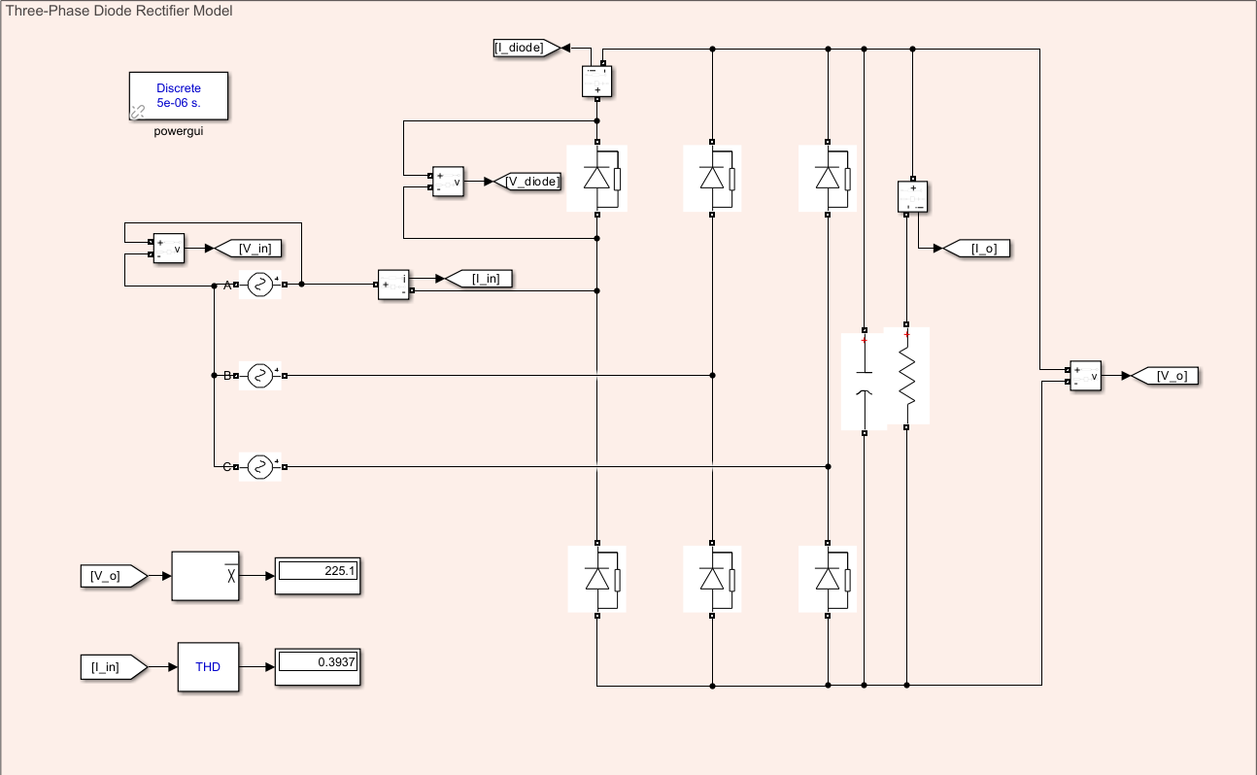
Figure 1: Three-Phase Diode Rectifier Model
Using the simulation model, we simulated the average DC output of the diode rectifier and the THD of the input. Observing the average output, it is concluded that this topology is suitable for obtaining an input to the buck converter. Moreover, the THD value of the input current is also compatible with our requirements.
The output voltage and output current waveforms are shown in Figure 2.
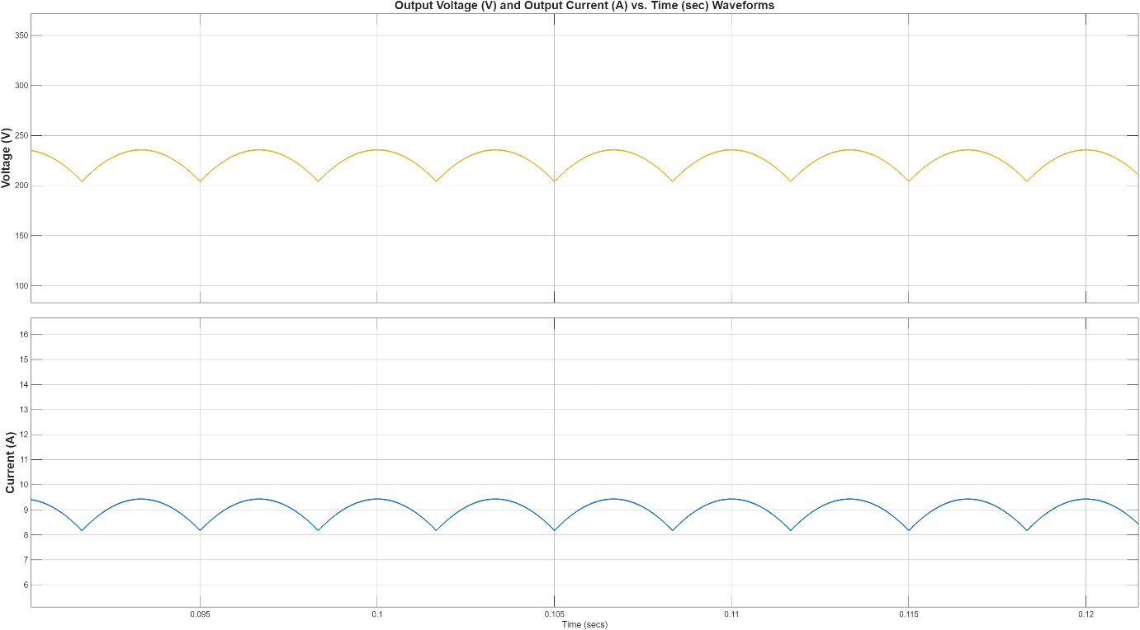
Figure 2: Output Voltage and Current Waveforms
When the output voltage waveform is observed, it can be concluded that the output voltage is within the desired values, approximately 225 V with a ripple of nearly 40 V. Adding a capacitor to the output terminal reduced the ripple such that it is applicable in the project. Moreover, the output current characteristics are compatible with the project. We used a 25 Ω resistor to observe the current characteristics, and it gave a value of approximately 8 A, which is consistent with the 225 V average DC output value. Next, we investigated the input voltage and current characteristics as shown in Figure 3.
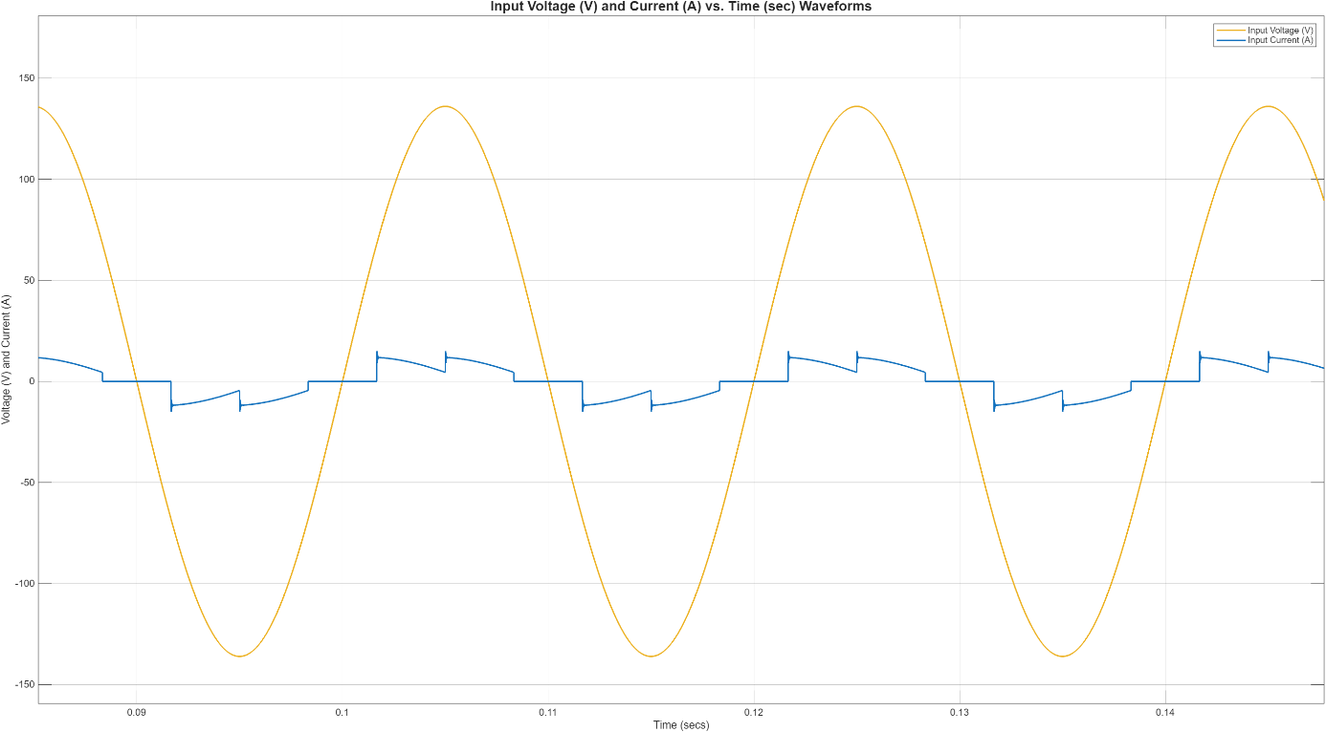
Figure 3: Input Voltage and Current Characteristics

When the input voltage waveform is observed, it can be concluded that the input voltage is a pure sinusoid, as we expected. However, the input current is highly distorted and not in a sinusoidal shape. This is because the filter output capacitor we connected to reduce the ripple. We concluded that this behavior is typical for a three-phase diode rectifier with a DC-link capacitor. Lastly, we investigated the characteristics of a single diode. The voltage and current waveforms can be seen in Figure 4.
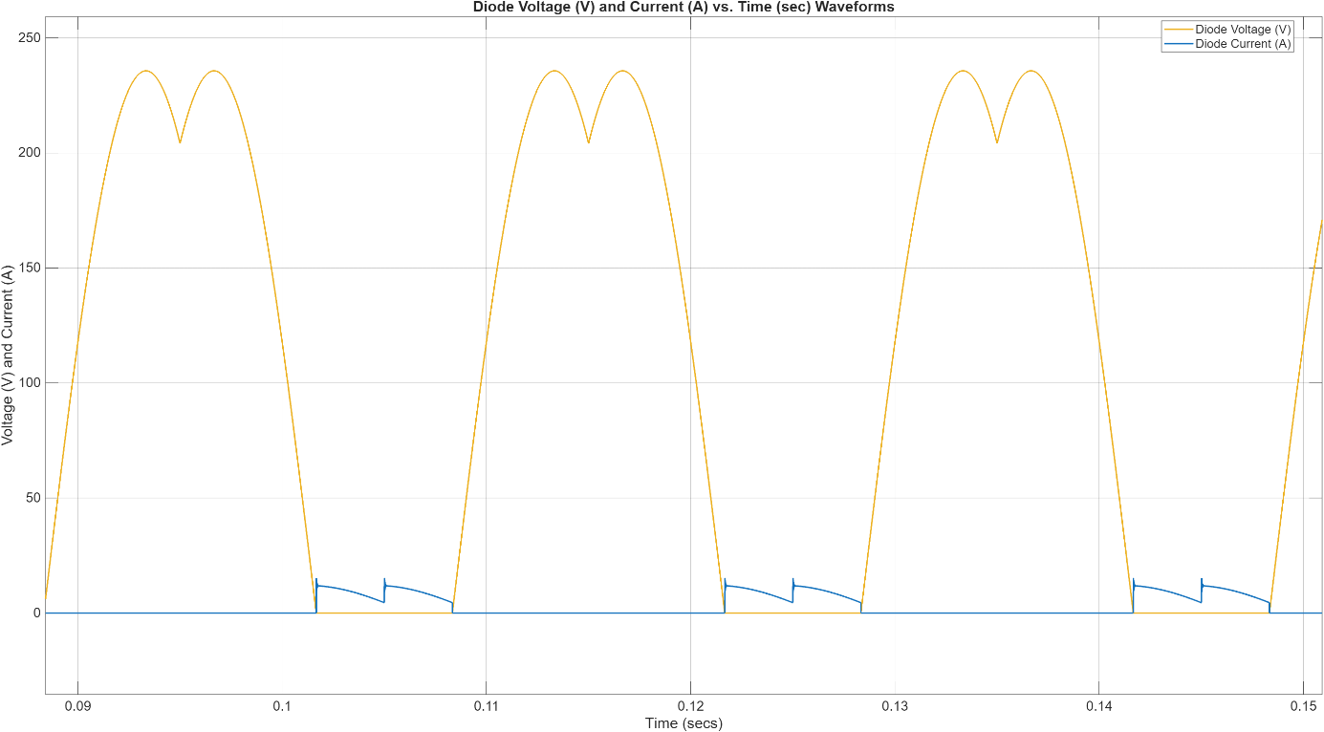
Figure 4: Diode Voltage and Current Waveforms
When the diode voltage and current waveforms are observed, it is concluded that the results coincide with the three-phase diode rectifier characteristics.
3.2. Buck Converter Simulation
For the buck converter, firstly, we calculated the values of the components, the maximum DC voltage value, the maximum duty cycle, and the maximum power. These requirements can be seen below.
$V_{out,max}=180 V, D_{max}=0.8, and P_{max}=2 kW$ (3)
$$I_{out,max}=\frac{2 kW}{180 V}=11.11 A \\ Choosing a switching frequency, f_{s}=20 kHz$$

We set the maximum ripple for the output current to be 20% and for the output voltage to be 5%. Considering these limitations and the worst-case scenario, we found the inductance and capacitance values that will be used in the design. The worst case in our design is the maximum output voltage case, where the duty cycle is 0.8, as we mentioned before. Calculations for the value of the inductor are as below.
$ΔI_{L}=I_{out,max} x 0.2=2.22 A$ (4)
$$L =\frac{V_{in}-V_{out}}{ΔI_{L} x f_{s}} \\ Then, L=\frac{225-180}{2.22 x 20 kHz}=1 mH approximately$$
Thus, we concluded that we could use a 1 mH inductor in the buck converter. Calculations for the value of the capacitor can also be seen below.
$ΔV_{o}=V_{out,max} x 0.05=9 V$ (5)

- Component Selection

